**ARDUINO UNO MAPPING**

**Port Registers**

Port registers allow for lower-level and faster manipulation of the i/o pins of the microcontroller on an Arduino board. The chips used on the Arduino board (ATmega168/ATmega328p) have three ports:

* • B (digital pin 8 to 13)
* • C (analog input pins)
* • D (digital pins 0 to 7)

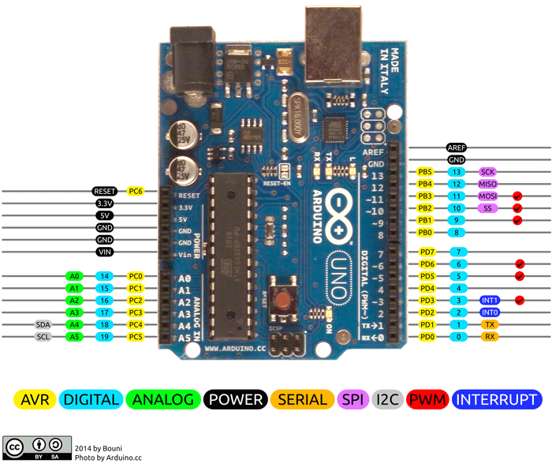

Each port is controlled by three registers, which are also defined variables in the Arduino language. The DDR register determines whether the pin is an INPUT or OUTPUT. The PORT register controls whether the pin is HIGH or LOW, and the PIN register reads the state of INPUT pins set to input with pin Mode(). DDR and PORT registers may be both written to and read. PIN registers correspond to the state of inputs and may only be read.

PORTD maps to Arduino digital pins 0 to 7

DDRD - The Port D Data Direction Register - read/write

PORTD - The Port D Data Register - read/write

PIND - The Port D Input Pins Register – read-only

PORTB maps to Arduino digital pins 8 to 13. The two high bits (6 & 7) map to the crystal pins and are not usable

DDRB - The Port B Data Direction Register - read/write

PORTB - The Port B Data Register - read/write

PINB - The Port B Input Pins Register – read-only

PORTC maps to Arduino analog pins 0 to 5. Pins 6 & 7 are only accessible on the Arduino Mini

DDRC - The Port C Data Direction Register - read/write

PORTC - The Port C Data Register - read/write

PINC - The Port C Input Pins Register – read-only

Each bit of these registers corresponds to a single pin; e.g., the low bit of DDRB, PORTB, and PINB refers to pin PB0 (digital pin 8).



